Programming Exercise 7:

*K*-means Clustering and Principal Component Analysis

Machine Learning

Student Name: Ethan Hitchcock

PeopleSoft ID: 1408202

Question (1) **(30 points)**

Please find the closest centroids class for the first 10 examples:

Centroids class = [ 1 3 2 1 1 1 1 1 1 1 ]

Question (2) **(25 points)**

Please compute the centroids after the first step of *K*- means:

Centroids =

[2.428301 3.157924

5.813503 2.633656

7.119387 3.616684]

Question (3) **(5 points)**

Show original and reconstructed bird image after you apply K-means

Image:

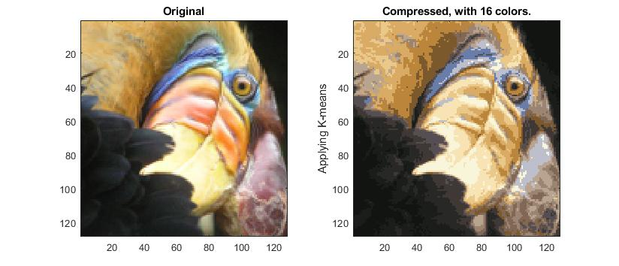

Question (4) **(20 points)**

Please compute the eigenvalues of the covariance matrix on example dataset

Eigenvalues =

[ 1.7008 0.2592 ]

Question (5) **(20 points)**

1. Please compute the projection of the first example:

Projection of the first example = 1.481274

1. Please compute the reconstructed approximation of the first example:

Approximation of the first example = [ -1.047419 -1.047419 ]